FIRST TERMINAL EXAMINATION SEPTEMBER- 2019
Marks obtained:

Total:
60
Name: ____________________________
Grade: I Section___
Subject: Mathematics
Date: 27.09.19
Time: 3 Hours

I. Choose the correct answer. 10x1=10
1. What comes after 7?
a. 6 b. 5 c.8
2. What is 3+2= _______
a. 8 b. 3 c. 5
3. What is 2-0= _______
a. 0 b. 2 c. 1
4. What is the next number?
3 5 7 _________
a. 4 b. 6 c. 9
5. Draw the next shapes?
__ _____
a. b. c.
6. Count the letters in the word “THINK ROOM”
a. 9 b. 5 c. 4

7. What comes between 13 _____ 15?
a. 12 b. 14 c. 16
8. Arrange them in the order from smallest to biggest.
9 8 7 6
a. 7 8 6 9 b. 6 7 8 9 c. 9 8 7 6
9. What is the symbol for greater than.
a. b. c.
10. What is symbol for equal to?
a. + b. = c. x
II. Match the following. 5x1=5
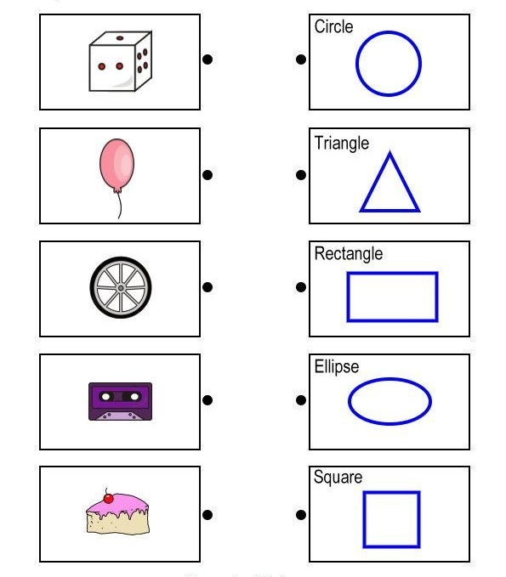

III. Fill in the blanks. 5x1=5
11. The ball has _______________________( straight / curved / straight and curved ) lines.
12. The table has _______________________ (straight / curved / straight and curved ) lines.
13. A square has ___________________ ( four / five / three) sides.
14. A triangle has ____________________ ( five / three / three) sides.
15.When we take away or subtract something from a quantity, it becomes _______________ ( more / less/ equal)
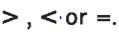
IV. Solve the following. 5x2=10
16. Fill in the boxes with
8 |  | 5
4 |  | 3

17. Write the number names.
11 __________________________________

20 ___________________________________

18. Add the following.
a. 4 pencils + 3 pencils + 1 pencil = __________________
b. 7 brushes + 2 burshes + 0 brush = ________________
19. Add the following.
a. 3+ 5+ 1 = ___________
b. 2+1+ 0 = ____________
20. Subtract the following.
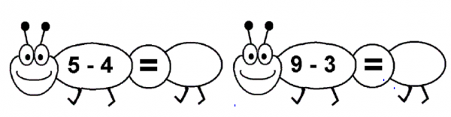
V. Solve the following. 5x5=25
21). 2 ducks are swimming in a pond. 5 more ducks enter the pond. How many ducks are there in the pond now?
Number of ducks in the pond =
Number of ducks entered =
___________________
Total number of ducks =
___________________
22. There are 6 eggs in a tray. Anu took away 2 eggs. How many eggs are left in the tray?
Number of eggs in the tray =
Number of eggs taken away=
___________________
Number of eggs left =
____________________
23. Use the given number to form addition and subtraction fact.
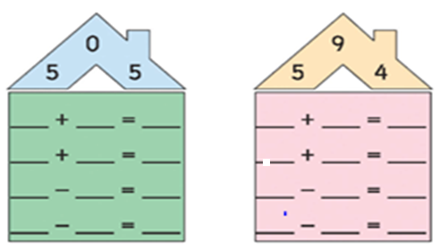
24.Count the objects, write the numbers and find the sum.
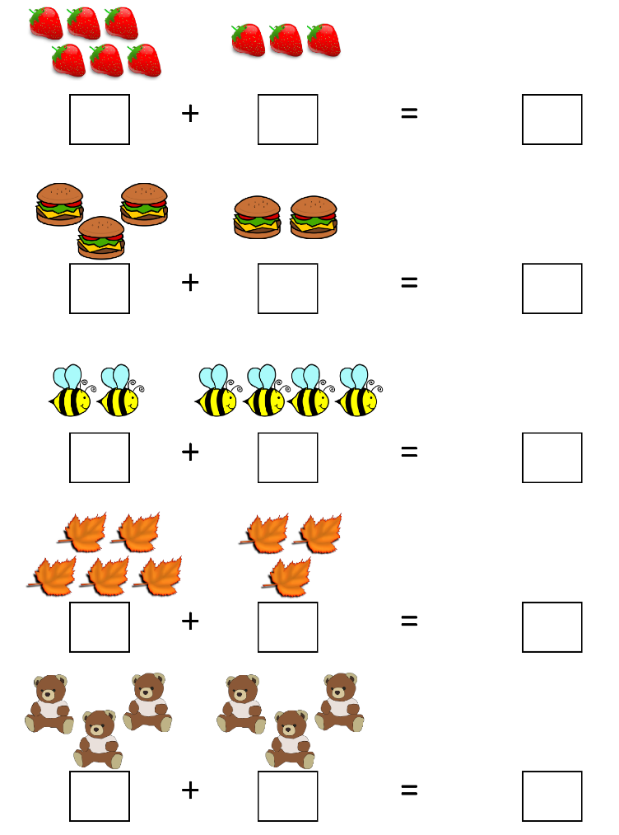
25. Subtract the numbers. 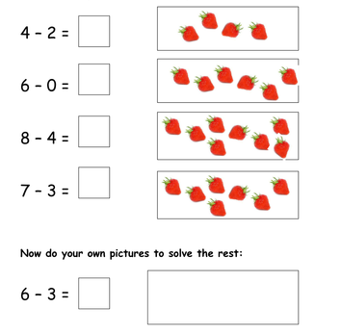
VI. Draw a pictures using different shapes and colour. 5

